Graphical user Interface and parsing data to another data types in java –

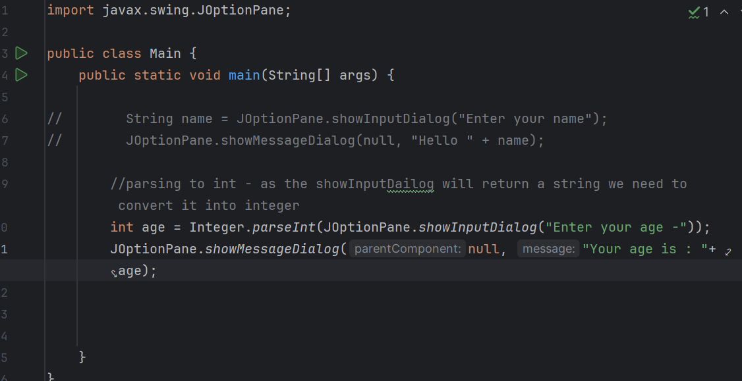

**Wrapper classes**

**Wrapper classes provides a way to use primitive data types as reference data types**

**Reference data types contain useful methods**

**Can be used with collections (ex.Arraylist)**

**Boolean – bool**

**Integer – int**

**Character – char**

**Double – double**

**aur**